Question 51—Question 60
QUESTION 51

What is the name of the Java concept that uses access modifiers to protect variables and hide them within a class?
- Encapsulation

- Inheritance

- Abstraction

- Instantiation

- Polymorphism

Answer: A

Explanation:

Using the private modifier is the main way that an object encapsulates itself and hide data from the outside world.

QUESTION 52

Given the code fragment:
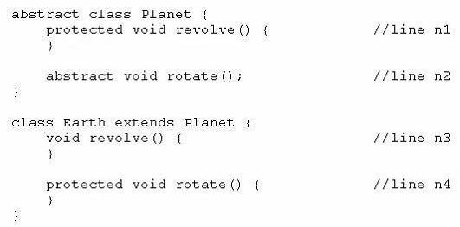

Which two modifications, made independently, enable the code to compile?

- Make the method at line n1 public.

- Make the method at line n2 public.

- Make the method at line n3 public.

- Make the method at line n3 protected.

- Make the method at line n4 public.

Answer: CD

Explanation:

We can’t assign weaker privileges in a subclass.

Method revolve() is declared protected in class Planet.

We can declare revolve() as public or protected in class Earth.

QUESTION 53
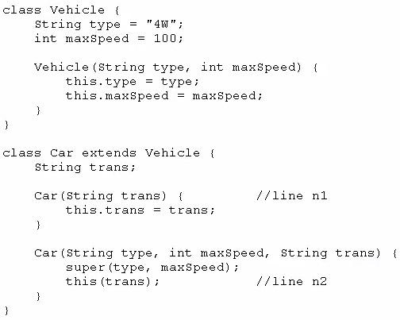
Given:

And given the code fragment:
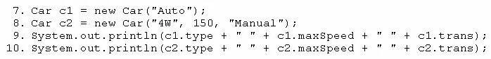

What is the result?

- 4W 100 Auto

4W 150 Manual

- Null 0 Auto

4W 150 Manual

- Compilation fails only at line n1

- Compilation fails only at line n2

- Compilation fails at both line n1 and line n2

Answer: E

Explanation:

Compilation fails at n1 because Vehicle hasn’t a default constructor

Compilation fails at n2 because this() must be the first statement in constructor body

QUESTION 54

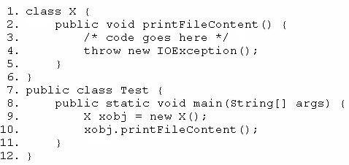
Given the code fragment:

Which two modifications should you make so that the code compiles successfully?

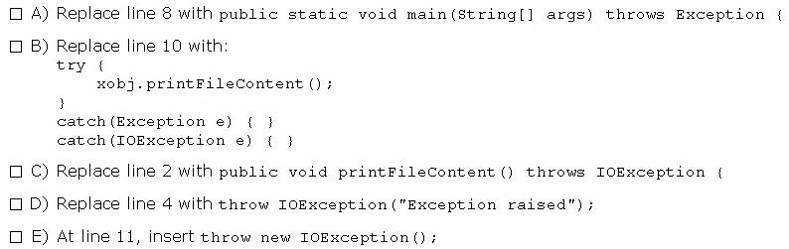

- Option A

- Option B

- Option C

- Option D

- Option E

Answer: AC

Explanation:

QUESTION 55

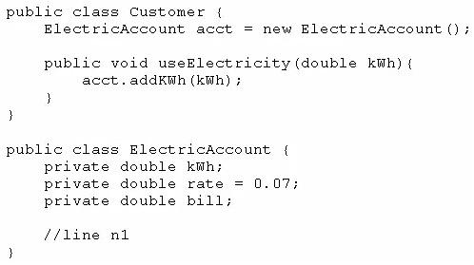
Given the following two classes:

How should you write methods in the ElectricAccount class at line n1 so that the member variable bill is always equal to the value of the member variable kwh multiplied by the member variable rate?

Any amount of electricity used by a customer (represented by an instance of the customer class) must contribute to the customer's bill (represented by the member variable bill) through the method useElectricity method.

An instance of the customer class should never be able to tamper with or decrease the value of the member variable bill.
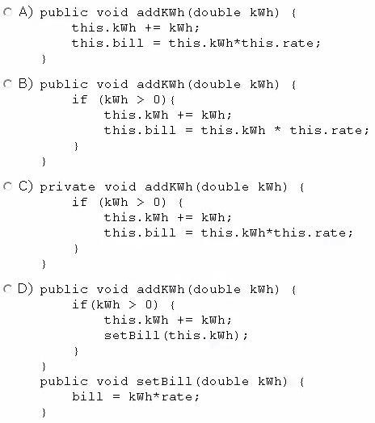

- Option A

- Option B

- Option C

- Option D

Answer: B

QUESTION 56

Given the code fragments:
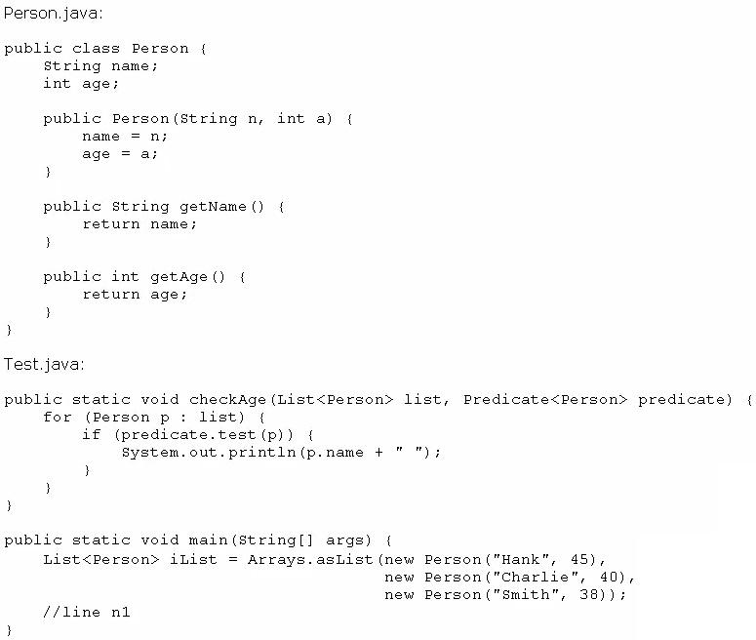

Which code fragment, when inserted at line n1, enables the code to print Hank?

- checkAge (iList, ( ) -> p. get Age ( ) > 40);

- checkAge(iList, Person p -> p.getAge( ) > 40);

- checkAge (iList, p -> p.getAge ( ) > 40);

- checkAge(iList, (Person p) -> { p.getAge() > 40; });

Answer: C

Explanation:

QUESTION 57

Given the code fragment:
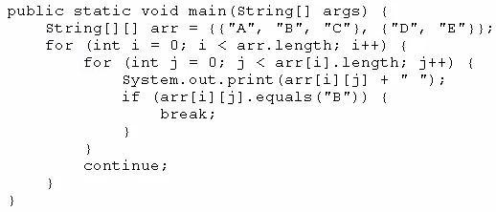

What is the result?

- A B C

- A B C D E

- A B D E

- Compilation fails.

Answer: C

QUESTION 58

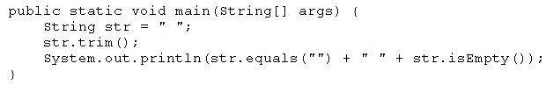
Given the code fragment:

What is the result?

- true true

- true false

- false false

- false true

Answer: C

QUESTION 59

Given:
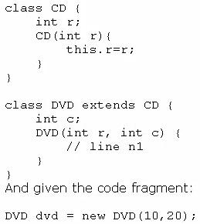

Which code fragment should you use at line n1 to instantiate the dvd object successfully?

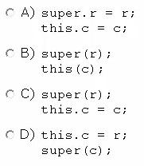

- Option A

- Option B

- Option C

- Option D

Answer: C

QUESTION 60
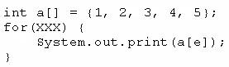
Given the code fragment:

Which option can replace xxx to enable the code to print 135?

- int e = 0; e < = 4; e++

- int e = 0; e < 5; e + = 2

- int e = 1; e < = 5; e + = 1

- int e = 1; e < 5; e+ =2

Answer: B

Explanation:

This loop prints the array elements with index 0, 2 and 4.

These elements are 1, 3, 5.
Question 61—Question 70
QUESTION 61

Which statement best describes encapsulation?

- Encapsulation ensures that classes can be designed so that only certain fields and methods of an object are accessible from other objects.

- Encapsulation ensures that classes can be designed so that their methods are inheritable.

- Encapsulation ensures that classes can be designed with some fields and methods declared as abstract.

- Encapsulation ensures that classes can be designed so that if a method has an argument MyType x, any subclass of MyType can be passed to that method.
Answer: A

Explanation:

QUESTION 62

Given the code fragment from three files:
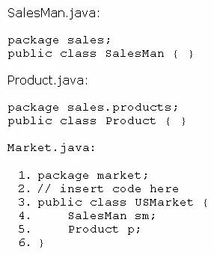

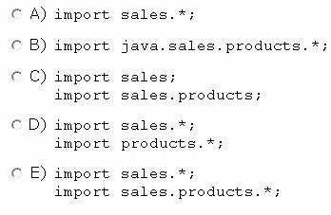
Which code fragment, when inserted at line 2, enables the code to compile?

- Option A

- Option B

- Option C

- Option D

- Option E

Answer: E

Explanation:

QUESTION 63

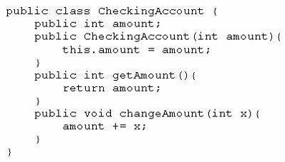
Given the following class:

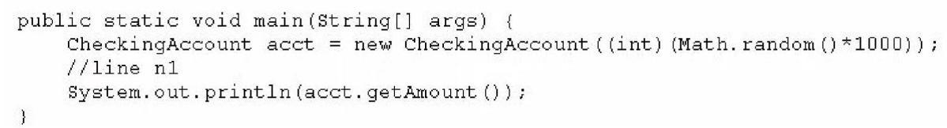
And given the following main method, located in another class:

Which three lines, when inserted independently at line n1, cause the program to print a o balance?
- this.amount = 0;

- amount = 0;

- acct (0) ;

- acct.amount = 0;

- acct. getAmount () = 0;

- acct.changeAmount(0);

- acct.changeAmount(-acct.amount);

- acct.changeAmount(-acct.getAmount());

Answer: DGH

Explanation:
A and B don’t compile because there isn’t a variable amount in method main.

C is wrong because we can’t call the constructor acct directly.

E is wrong because we can’t make a method on acct equal to 0.

F is wrong because does not change variable amount of class CheckingAccount

QUESTION 64

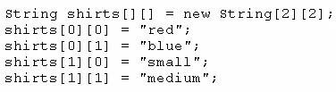
Given the code fragment:

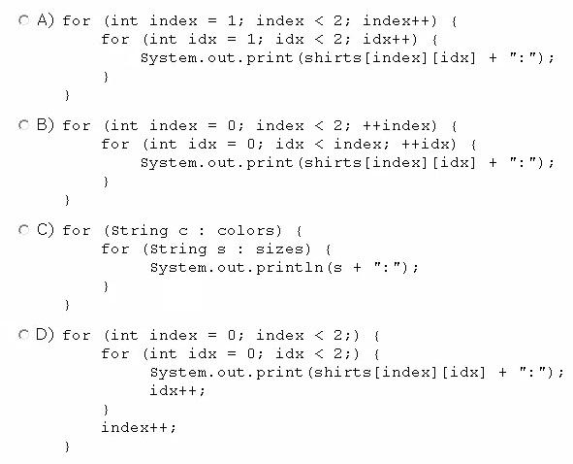
Which code fragment prints red: blue: small: medium?

- Option A

- Option B

- Option C

- Option D

Answer:D

QUESTION 65

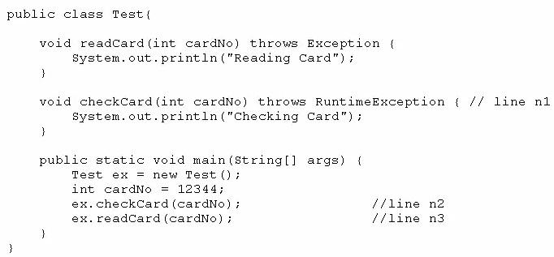
Given the code fragment:

What is the result?
- Reading Card
Checking Card

- Compilation fails only at line n1.

- Compilation fails only at line n2.

- Compilation fails only at line n3.

- Compilation fails at both line n2 and line n3.

Answer: D

Explanation:

Exception is a checked exception so we are required to check it with try/catch or be declared in method main.

QUESTION 66

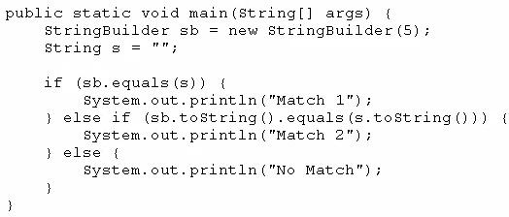
Given the code fragment:

What is the result?

- Match 1

- Match 2

- No Match

- A NullPointerException is thrown at runtime.

Answer: B

Explanation:

It will compare the string contents of the StringBuilder with string object.

QUESTION 67

Given:
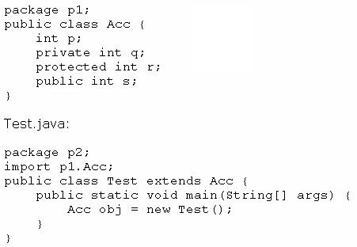

Which statement is true?

- Both p and s are accessible by obj.

- Only s is accessible by obj.

- Both r and s are accessible by obj.

- p, r, and s are accessible by obj.

Answer: B (Correct Ans: C)

Explanation:

Only s is accessible because it is the only public member of class Acc.

QUESTION 68

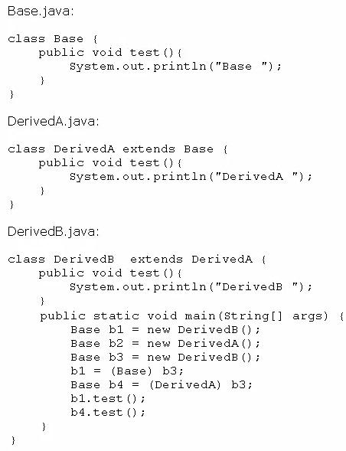
Given:

What is the result?

- Base DerivedA

- Base DerivedB

- DerivedB DerivedB

- DerivedB DerivedA
- A classcast Except ion is thrown at runtime.

Answer: C

QUESTION 69

Given the code fragment:

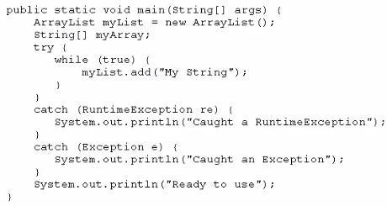

What is the result?

- Execution terminates in the first catch statement, and caught a RuntimeException is printed to the console.

- Execution terminates In the second catch statement, and caught an Exception is printed to the console.

- A runtime error is thrown in the thread "main".

- Execution completes normally, and Ready to use is printed to the console.

- The code fails to compile because a throws keyword is required.

Answer: C

Explanation:

while loop is an infinite loop so the program ends with an OutOfMemoryError. This error can’t be caught with Exception nor RuntimeException.

QUESTION 70

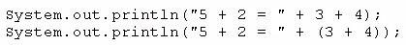
Given:

What is the result?
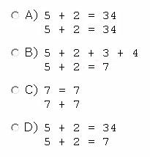
- Option A

- Option B

- Option C

- Option D

Answer: D

Explanation:

If neither operand of + is a reference to a String object, the operator is the arithmetic addition operator, not the string concatenation operator. Note that Java does not allow a program to define overloaded operators. However, the language defines the + operator to have a meaning that is fundamentally different from arithmetic addition if at least one of its operands is a String object.

The way in which Java decides if + means arithmetic addition or string concatenation means that the use of parentheses can alter the meaning of the + operator.

See “String Concatenation Operator +” at

Question 71—Question 80
QUESTION 71

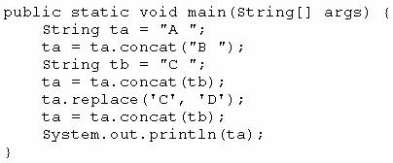
Given:

What is the result?

- A B C D

- A C D

- A B C

- A B D

- A B D C

Answer: C

Explanation:

The line “ta.replace('C', 'D');” returns a string that is never assigned to ta.

QUESTION 72

Given the code fragment:

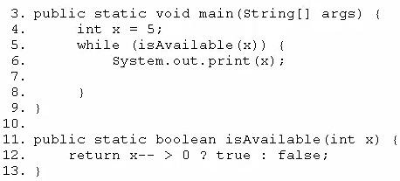

Which modification enables the code to print 54321?

- Replace line 6 with System, out. print (--x) ;

- At line 7, insert x --;

- Replace line 6 with --x; and, at line 7, insert system, out. print (x);

- Replace line 12 With return (x > 0) ? false: true;

Answer: B

QUESTION 73

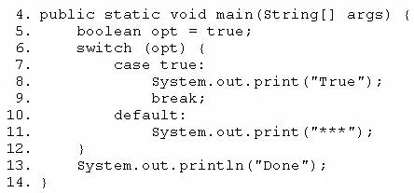
Given the code fragment:

Which modification enables the code fragment to print TrueDone?

- Replace line 5 With String result = "true"; Replace line 7 with case "true":

- Replace line 5 with boolean opt = l; Replace line 7 with case 1=

- At line 9, remove the break statement.

- Remove the default section.

Answer: A

Explanation:

Switch statements with String cases were implemented in Java SE 7.
QUESTION 74

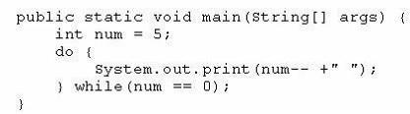
Given the following main method:

What is the result?

- 5 4 3 2 1 0

- 5 4 3 2 1
- 4 2 1
- 5
- Nothing is printed

Answer: D

Explanation:

The loop body executes only once because on the while condition num = 4.

When the execution reaches System.out.print, num = 5.

QUESTION 75

Given the code fragment:
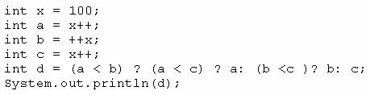

What is the result?

- 100

- 101

- 102

- 103

- Compilation fails

Answer: E

Explanation:

Compilation fails with error ": expected" because we have three ternary operators but only two colons.

QUESTION 76

Given:
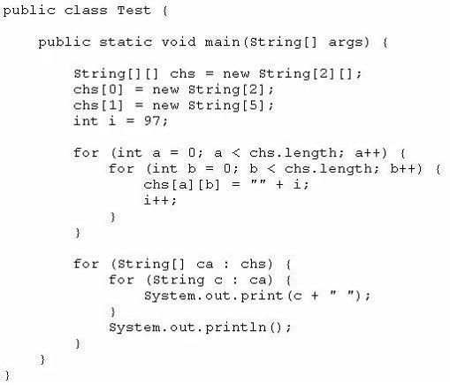

What is the result?

- 97 98

99 100 null null null

- 91 98

99 100 101 102 103

- Compilation rails.

- A NullPointerException is thrown at runtime.

- An ArraylndexOutOfBoundsException is thrown at runtime.

Answer: A

Explanation:

When we exit first loop we have

chs[0][0] = 97

chs[0][1] = 98

chs[1][0] = 99

chs[1][1] = 100

chs[1][2] = null;
chs[1][3] = null;

chs[1][4] = null;

The second loop prints these values.

QUESTION 77

Given the code fragment:

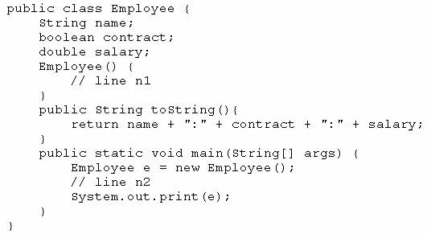

Which two modifications, when made independently, enable the code to print joe:true: 100.0?
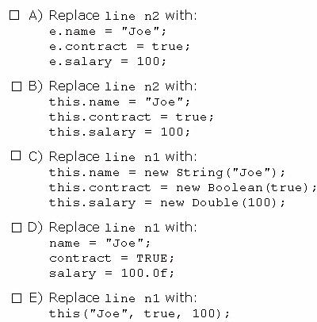

- Option A

- Option B

- Option C

- Option D

- Option E

Answer: AC

QUESTION 78

View the exhibit:

public class Student {

public String name = "";

public int age = 0;

public String major = "Undeclared";

public boolean fulltime = true;

public void display() {

System.out.println("Name: " + name + " Major: " + major); }

public boolean isFullTime() {

return fulltime;

}

}

Which line of code initializes a student instance?

- Student student1;

- Student student1 = Student.new();

- Student student1 = new Student();

- Student student1 = Student();

Answer: C

QUESTION 79

What should keyword1 and keyword2 be respectively, in oreder to produce output 2345?
int [] array = {1,2,3,4,5};

for (int i: array) {

if ( i < 2) {

keyword1 ;

}

System.out.println(i);

if ( i == 3) {

keyword2 ;

}}

- continue, break

- break, break

- break, continue

- continue, continue

Answer: D

QUESTION 80
What is the result?

int i, j=0;

i = (3* 2 +4 +5 ) ;

j = (3 * ((2+4) + 5)); System.out.println("i:"+ i + "\nj":+j);

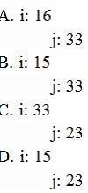

- Option A

- Option B
- Option C

- Option D

Answer: B

Question 81—Question 90
QUESTION 81

What is the result?
boolean log3 = ( 5.0 != 6.0) && ( 4 != 5);
boolean log4 = (4 != 4) || (4 == 4);
System.out.println("log3:"+ log3 + \nlog4" + log4);
- log3:false

log4:true

- log3:true

log4:true

- log3:true

log4:false

- log3:false

log4:false

Answer: B

QUESTION 82

Which statement will emoty the contents of a StringBuilder variable named sb?

- sb.deleteAll();
- sb.delete(0, sb.size());

- sb.delete(0, sb.length());

- sb.removeAll();

Answer: C

QUESTION 83

What is the result?

Class StaticField {

static int i = 7;

public static void main(String[] args) {

StaticFied obj = new StaticField();

obj.i++;

StaticField.i++;

obj.i++;

System.out.println(StaticField.i + " "+ obj.i);

}

}
- 10 10

- 8 9

- 9 8

- 7 10

Answer: A

QUESTION 84

Which two are valid array declaration?

- Object array[];

- Boolean array[3];

- int[] array;

- Float[2] array;

Answer: AC

QUESTION 85

Given:
class Overloading {

int x(double d) {

System.out.println("one");

return 0;

}

String x(double d) {

System.out.println("two");

return null;

}

double x(double d) {

System.out.println("three");

return 0.0;

}

public static void main(String[] args) { new Overloading().x(4.0); }
}

What is the result?

- one

- two

- three

- Compilation fails.

Answer: D

QUESTION 86

Given:
public class MainMethod {

void main() {

System.out.println("one");

}

static void main(String args) {
System.out.println("two");

}

public static void main(String[] args) { System.out.println("three"); }

void mina(Object[] args) {

System.out.println("four");

}

}

What is printed out when the program is excuted?

- one

- two

- three

- four

Answer: C

QUESTION 87

Given:
public class ScopeTest {

int j, int k;

public static void main(String[] args) { ew ScopeTest().doStuff(); } void doStuff() {

nt x = 5;

oStuff2();

System.out.println("x");

}

void doStuff2() {

nt y = 7;

ystem.out.println("y");

or (int z = 0; z < 5; z++) {

ystem.out.println("z");

ystem.out.println("y");

}

Which two items are fields?

- j

- k

- x

- y

- z

Answer: AB

QUESTION 88

A method is declared to take three arguments.

A program calls this method and passes only two arguments.

What is the results?

- Compilation fails.

- The third argument is given the value null.

- The third argument is given the value void.

- The third argument is given the value zero.

- The third argument is given the appropriate falsy value for its declared type.

- An exception occurs when the method attempts to access the third argument.

Answer: A

QUESTION 89

Which three are valid replacements for foo so that the program will compiled and run?
public class ForTest {

public static void main(String[] args) { int[] arrar = {1,2,3}; for ( foo ) {
}

}

}
- int i: array
- int i = 0; i < 1; i++

- ;;
- ; i < 1; i++
- ; i < 1;

Answer: ABC

QUESTION 90

Gven:
public class SampleClass {

public static void main(String[] args) {

AnotherSampleClass asc = new AnotherSampleClass();
SampleClass sc =new SampleClass();

sc = asc;

System.out.println("sc: " + sc.getClass());

System.out.println("asc: " + asc.getClass());

}}

class AnotherSampleClass extends SampleClass {

}

What is the result?

- sc: class Object

asc: class AnotherSampleClass

- sc: class SampleClass

asc: class AnotherSampleClass

- sc: class AnotherSampleClass

asc: class SampleClass

- sc: class AnotherSampleClass

asc: class AnotherSampleClass

Answer: D

Question 91—Question 100
QUESTION 91

Given the code fragment:
int b = 3;

if ( !(b > 3)) {

System.out.println("square");

}{

System.out.println("circle");

}

System.out.println("...");

What is the result?

- square...

- circle...

- squarecircle...

- Compilation fails.

Answer: C

QUESTION 92

What is the proper way to defined a method that take two int values and returns their sum as an int value?
- int sum(int first, int second) { first + second; }

- int sum(int first, second) { return first + second; }

- sum(int first, int second) { return first + second; }

- int sum(int first, int second) { return first + second; }

- void sum (int first, int second) { return first + second; }

Answer: D

Explanation:

Incorrect answers:

A: no return statement

QUESTION 93

Which two are Java Exception classes?

- SercurityException

- DuplicatePathException

- IllegalArgumentException

- TooManyArgumentsException

Answer: AC

QUESTION 94
Given the for loop construct:
for ( expr1 ; expr2 ; expr3 ) {

statement;

}
Which two statements are true?
- This is not the only valid for loop construct; there exits another form of for loop constructor.

- The expression expr1 is optional.

it initializes the loop and is evaluated once, as the loop begin.

- When expr2 evaluates to false, the loop terminates.

It is evaluated only after each iteration through the loop.

- The expression expr3 must be present.
It is evaluated after each iteration through the loop.

Answer: AB

Explanation:

A is true because there are two types of for loop in Java. Classic and Enhanced.

B is true because we can run code like for( ; expr2 ; expr3).

C is false because expr2 is evaluated BEFORE each iteration.

D is false because we can run code like for(expr1; expr2; ).

http://www.java-tips.org/java-se-tips-100019/24-java-lang/480-the-enhanced-for-loop.html

QUESTION 95

What is the result?
public class StringReplace {

public static void main(String[] args) {

String message = "Hi everyone!";

System.out.println("message = " + message.replace("e", "X")); }

}

- message = Hi everyone!

- message = Hi XvXryonX!

- A compile time error is produced.

- A runtime error is produced.

- message =

- message = Hi Xveryone!

Answer: B

QUESTION 96

Which two statements are true for a two-dimensional array?

- It is implemented as an array of the specified element type.

- Using a row by column convention, each row of a two-dimensional array must be of the same size

- At declaration time, the number of elements of the array in each dimension must be specified

- All methods of the class Object may be invoked on the two-dimensional array.

Answer: AD

QUESTION 97

Which three statements are benefits of encapsulation?

- allows a class implementation to change without changing t he clients

- protects confidential data from leaking out of the objects

- prevents code from causing exceptions

- enables the class implementation to protect its invariants

- permits classes to be combined into the same package

- enables multiple instances of the same class to be created safely

Answer: ABD

QUESTION 98

Given the code fragment:
- ArrayList<Integer> list = new ArrayList<>(1);

- list.add(1001);

- list.add(1002);

- System.out.println(list.get(list.size()));

What is the result?

- Compilation fails due to an error on line 1.

- An exception is thrown at run time due to error on line 3

- An exception is thrown at run time due to error on line 4

- 1002

Answer: C
Explanation:

The code compiles fine.

At runtime an IndexOutOfBoundsException is thrown when the second list item is added.

QUESTION 99

Given the code fragment:

Which code fragment prints blue, cyan, ?
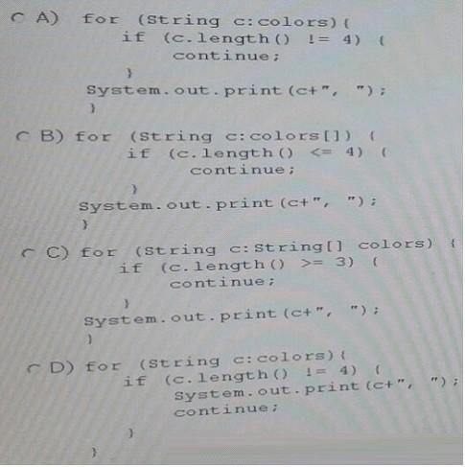

- Option A

- Option B

- Option C

- Option D

Answer: A

QUESTION 100
View the Exhibit.

public class Hat {

public int ID =0;

public String name = "hat";

public String size = "One Size Fit All"; public String color="";

public String getName() { return name; }

public void setName(String name) {

this.name = name;

}

}

Given:
public class TestHat {

public static void main(String[] args) { Hat blackCowboyHat = new Hat(); }

}

Which statement sets the name of the Hat instance?

- blackCowboyHat.setName = "Cowboy Hat";

- setName("Cowboy Hat");

- Hat.setName("Cowboy Hat");

- blackCowboyHat.setName("Cowboy Hat");

